Bangladesh University of Engineering and Technology

Department of Electrical and Electronic Engineering

EEE 468 (July 2023)

VLSI Laboratory

**Final Project Report**

**Section: G1 Group: 08**

16-bit Ripple Carry Adder

**Course Instructors:**

**Nafis Sadik, Lecturer**

**Rafid Hassan Palash, Part-Time Lecturer**

**Signature of Instructor: ___________________________________________________**

**Academic Honesty Statement:**

**IMPORTANT! Please carefully read and sign the Academic Honesty Statement, below. Type the student ID and name, and put your signature. *You will not receive credit for this project experiment unless this statement is signed in the presence of your lab instructor.***

*“In signing this statement, We hereby certify that the work on this project is our own and that we have not copied the work of any other students (past or present), and cited all relevant sources while completing this project. We understand that if we fail to honor this agreement, We will each receive a score of ZERO for this project and be subject to failure of this course.”*

|  |  |  |
| --- | --- | --- |
| **Signature:___________________________**  **Full Name: Tasmin Khan**  **Student ID: 1906055** | **Signature: ______________________**  **Full Name: Tanvir Hossain**  **Student ID: 1906040** |  |
|  |  |  |  |

1. Contents

1 Abstract 2

2 Introduction 2

3 Design 4

3.1 Problem Formulation 4

3.2 Design Method 4

3.3 Tools Used 5

4 Design 5

4.1 Verilog Code 5

5 Testbench 6

5.1 Flat Testbench 6

5.2 Layered Testbench: 8

6 Synthesis and Optimization 19

6.1 Optimization 22

7 Physical Design (PnR) 28

8 Reflection on Individual and Team work Error! Bookmark not defined.

9 Future Works 36

10 References 36

# Abstract

|  |
| --- |
| Adders are digital circuits used for binary addition. They are fundamental in arithmetic operations, forming the basis of components like ALUs, multipliers, and processors. A 16- bit adder have two 16-bit inputs and a carry in and a 16-bit output sum and a carryout. The adder needs to be designed, verified, synthesized and we need to design the layout |

# Introduction

The half adder adds two single-bit inputs, A and B. The result is 0, 1, or 2, so two bits are required to represent the value; they are called the sum S and carry-out ‘Cout’.

A **full adder** is a fundamental combinational logic circuit used in digital electronics to perform the addition of three binary inputs: two significant bits and a carry input Cin​ from a previous stage. It generates two outputs: the **sum** and the **carry-out** Cout. The sum represents the result of adding the three input bits, while the carry-out indicates whether there is an overflow (i.e., when the total exceeds the capacity of a single bit).

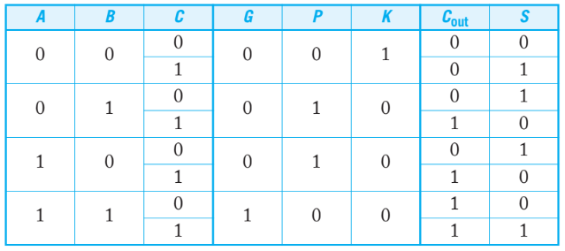

Figure 1.1: truth table for a full adder

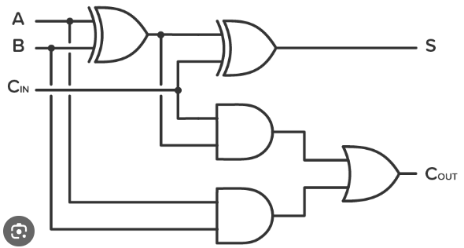

Figure 1.2: full adder circuit diagram

We have to design a 16 bit full adder with the propagate generate logic. For a full adder, it is sometimes useful to define Generate (G), Propagate (P), and Kill (K) signals. The adder generates a carry when Cout is true independent of Cin, so G = A · B. The adder propagates a carry; i.e., it produces a carry-out if and only if it receives a carry-in, when exactly one input is true: P = A xor B.

The full adder logic is:

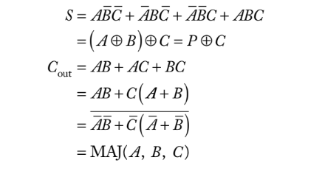

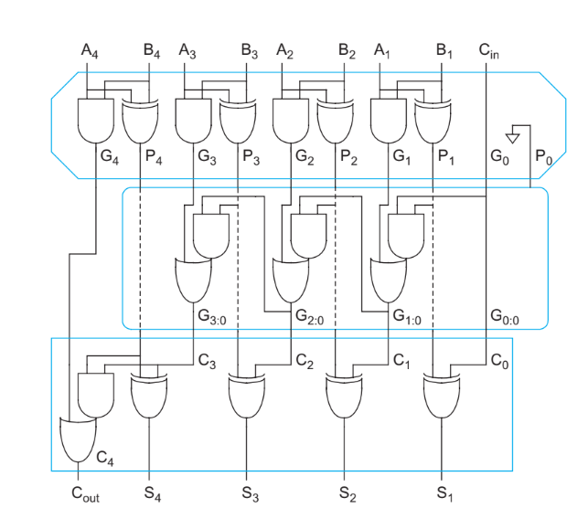

Figure 1.3: 4-bit carry-ripple adder using PG logic

The expressions for the carry in for the stages in terms of PG logic is as follows:

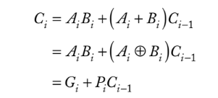

We have to design a 16-bit ripple carry adder. So, our Verilog module should look like below

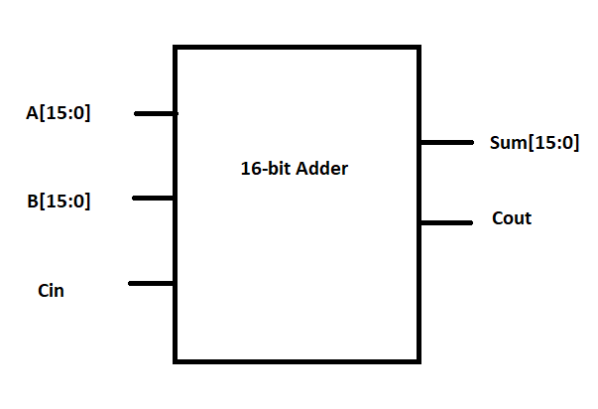

# Design

## Problem Formulation

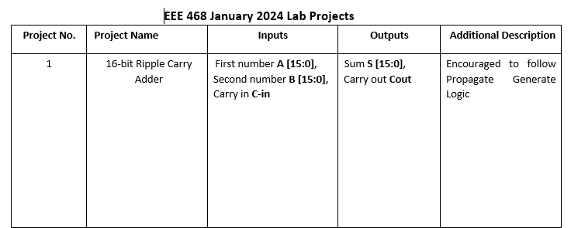

## Design Method

1. Design Code
2. Verification using Directed and Layered Testbench
3. RTL Synthesis
4. Power and Area Optimization
5. PnR Analysis
6. PnR Optimization

## Tools Used

Cadence CAD Tools:

1. NCSim for simulation
2. Simvision for visualization
3. Genus for RTL synthesis
4. Innovus for PnR

# Design

## Verilog Code

**Ripple Carry Adder Module without clock:**

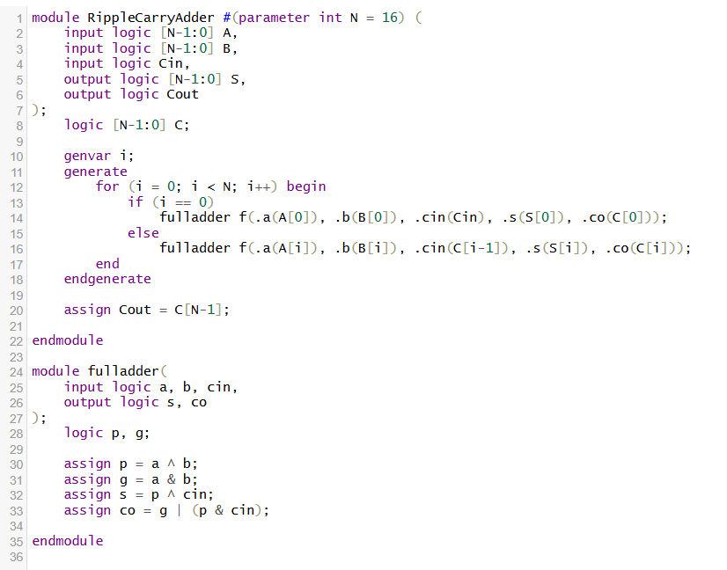

**Ripple Carry Adder Module with Clock:**

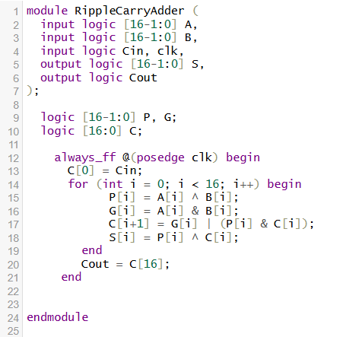

The module with clock is used to get the results at the positive edge of the clock also following the Propagate Generate logic.

# Testbench

## Flat Testbench

**Code:**

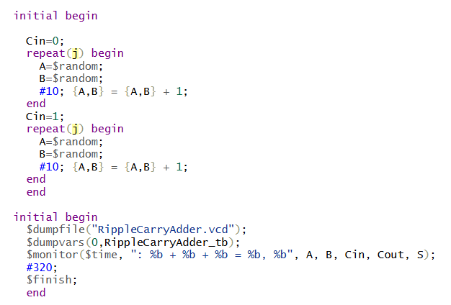

**Output in binary:**

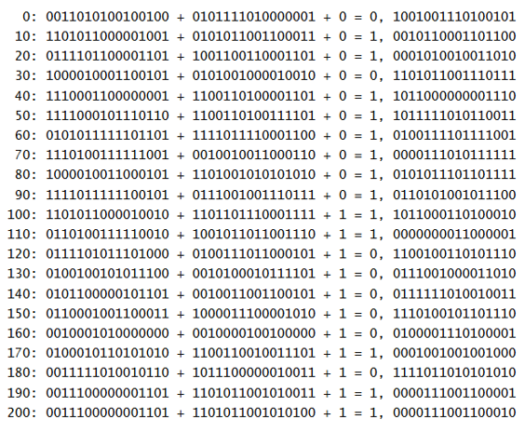

**Flat Testbench Result printed in decimal:**

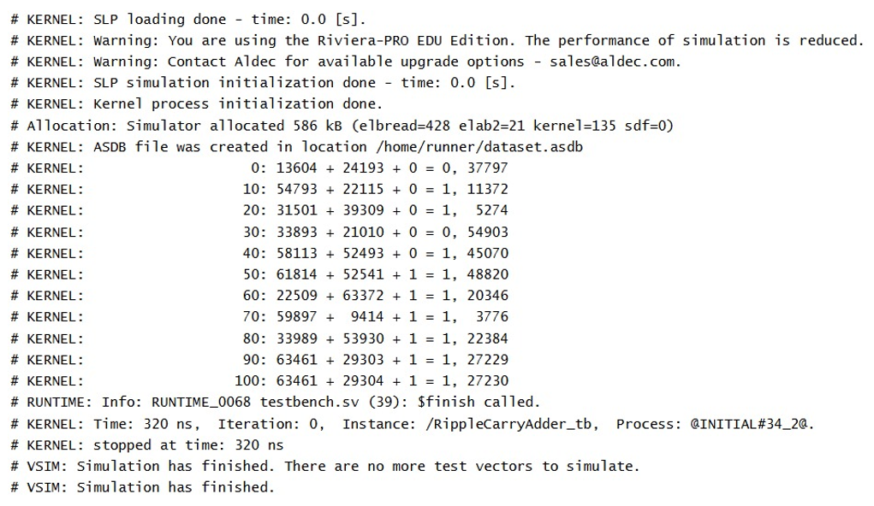

## Layered Testbench:

**Testbench module:**

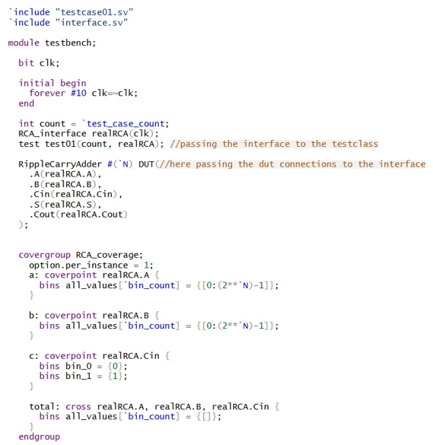

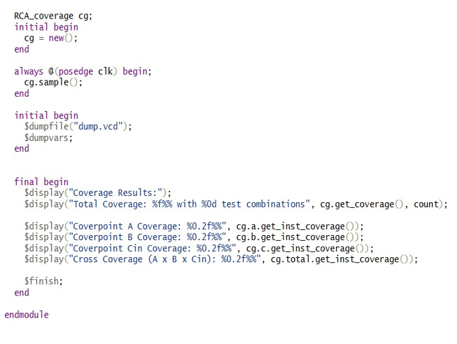

Here we introduced coverage group with cover point for each input signal as well as a cross coverage for all the signals. We also took sampling for the coverpoints at each posedhe of the clock.

**Interface.sv**

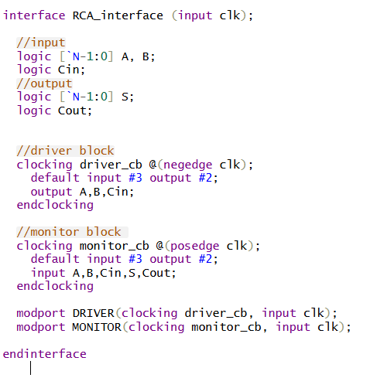

**Driver Class:**

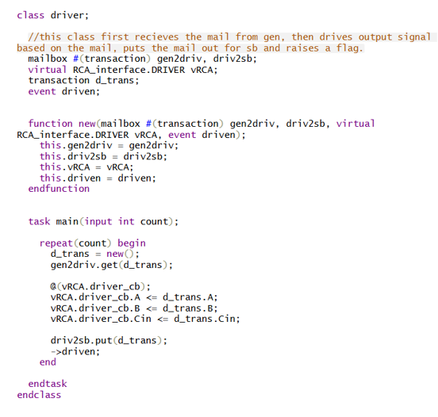

**Scoreboard.sv**

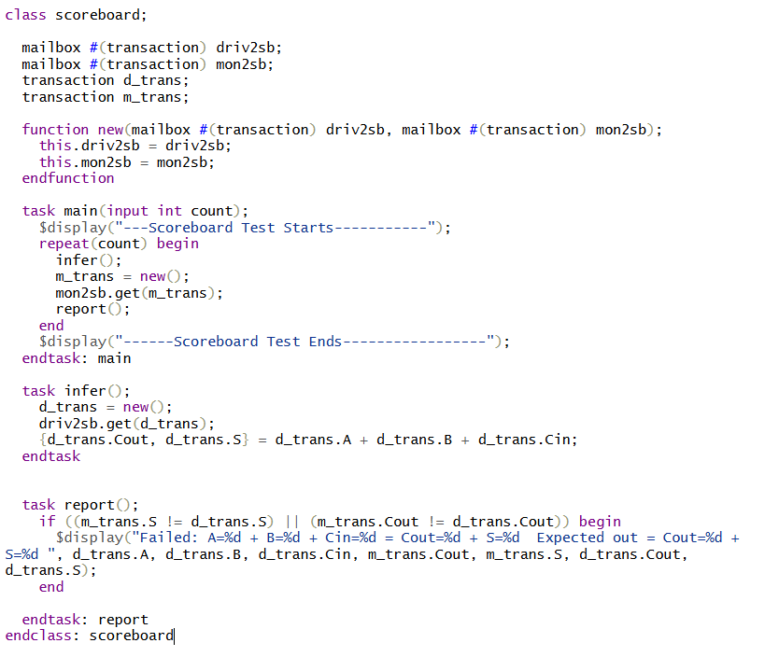

**Monitor Class**

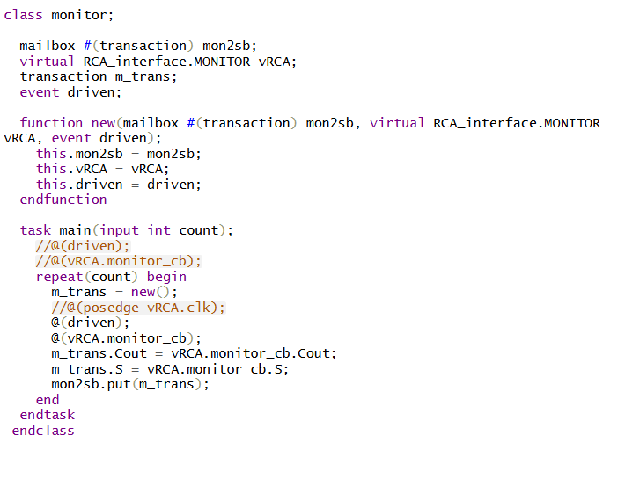

**Generator Class:**

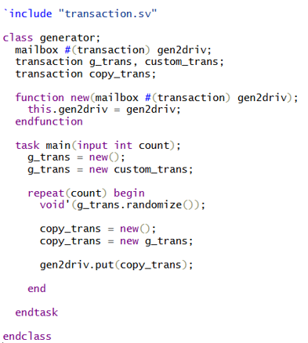

**Enviroment Class:**

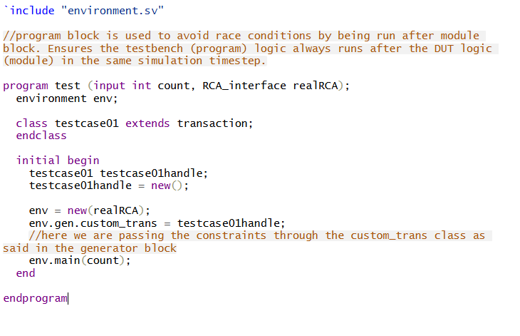

**Transaction.sv**

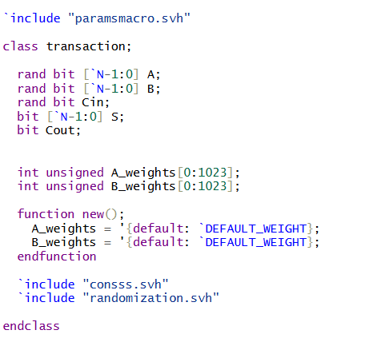

**Constraint Header File**

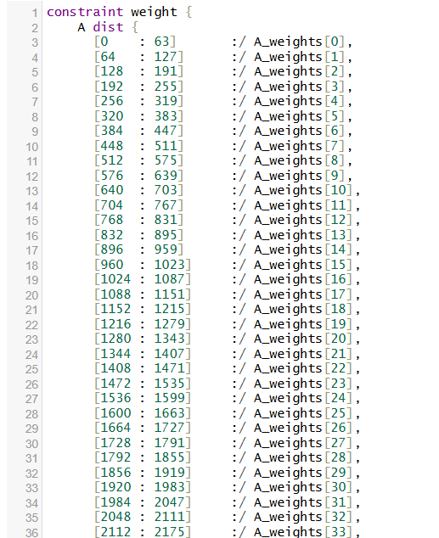 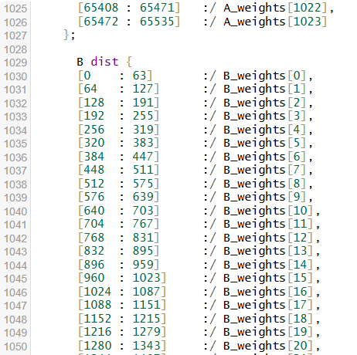

We declared the transaction class with randomization function for each input signal and a distribution weight for each bin. We took 1024 bins and so there were 1024 weights declared for them, We initially started all the bins with the same weight and then reduced the weight by a defined penalty number each time a number was produced from that bin. A conditional statement was checked beforehand to ensure no negative weight is not introduced. Another conditional statement is implemented to reset the weights when all the weights hit the minimum.

This way the distribution is skewed making the probability of the bin that is not hit, higher after every iteration. As a result, achieving coverage is now possible with fewer epochs,

This distribution skewing is done by declaring a pre randomization function that is invoked automatically every time before randomization function is called. We also introduced a conditional statement to avoid cases where no value has been assigned to A or B yet to skip unnecessary distribution skewing.

The code for the pre randomization function and the result of skewing after each iteration is shown in the next page.

**Pre-Randomization Header File**

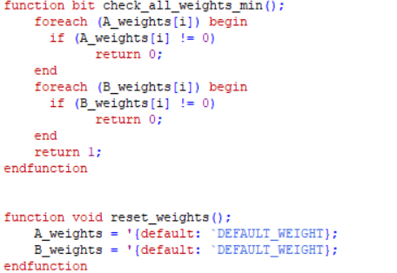

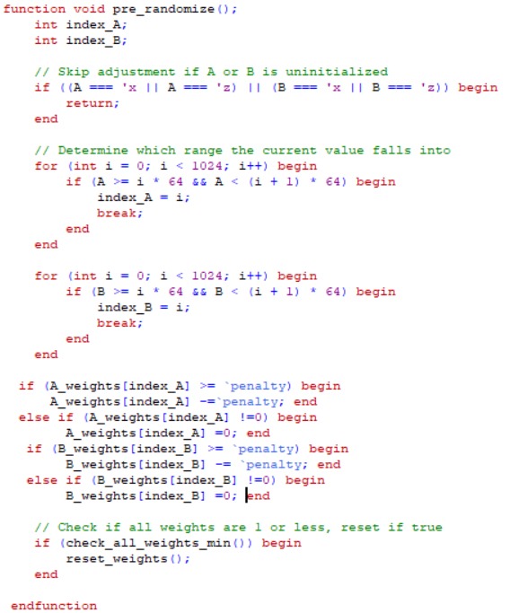

**Pre-Randomization**

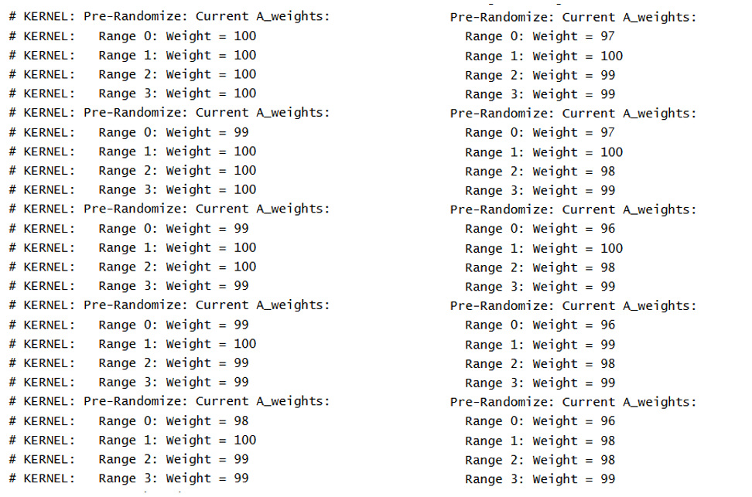

**Testbench Coverage plots:**

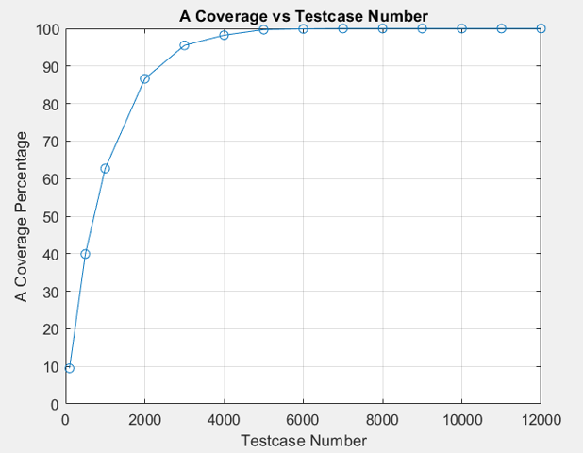

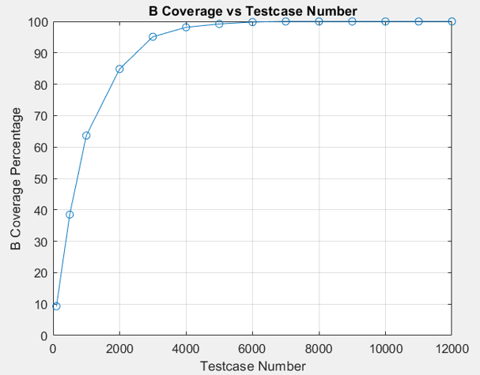

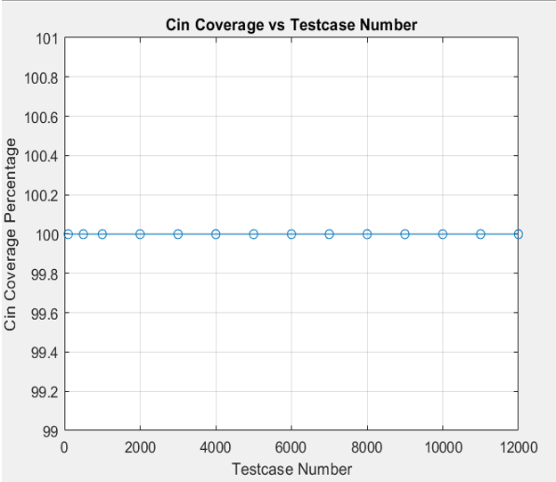

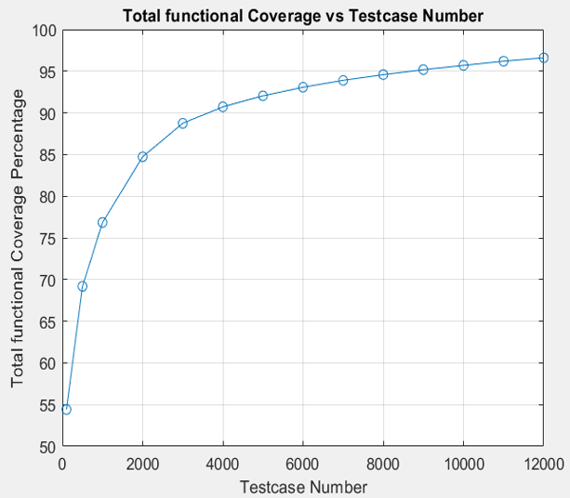

**Relationship of Coverage with penalty plots:**

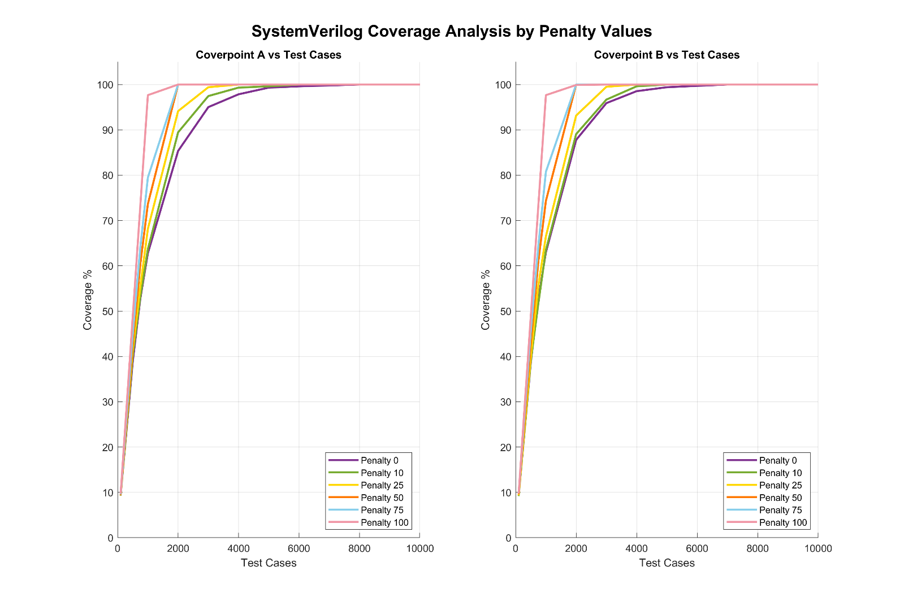

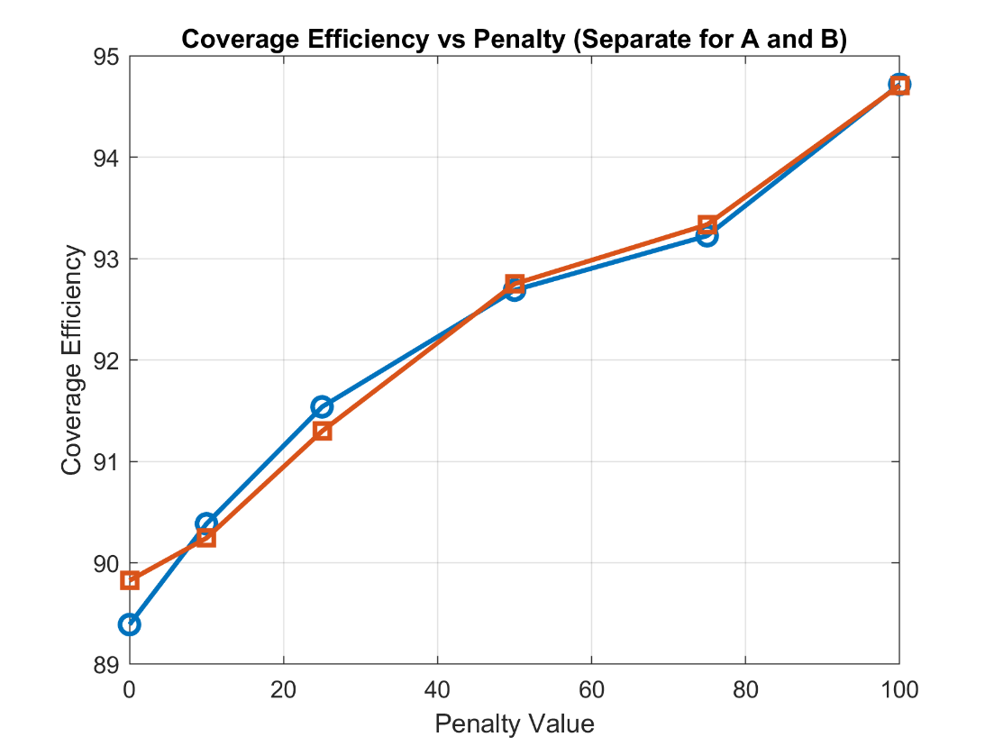

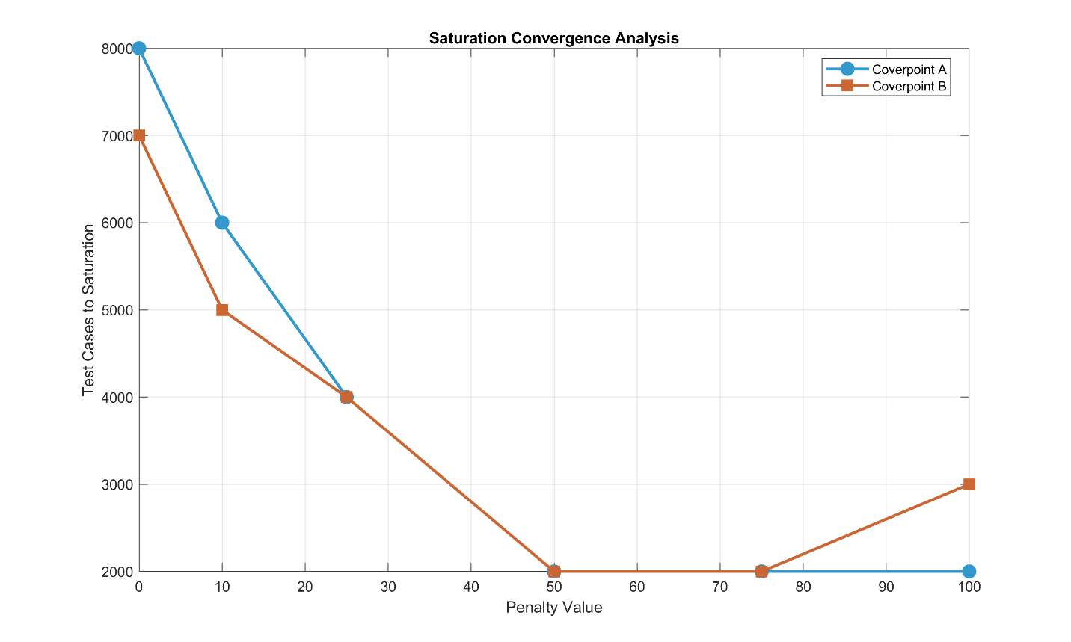

# Synthesis and Optimization

We need to tune these parameters:

1. Input Delay
2. Output Delay
3. Frequency

Then our optimization targets are:

1. Power
2. Area
3. Delay

**Synthesis of adder module without clock in Genus:**

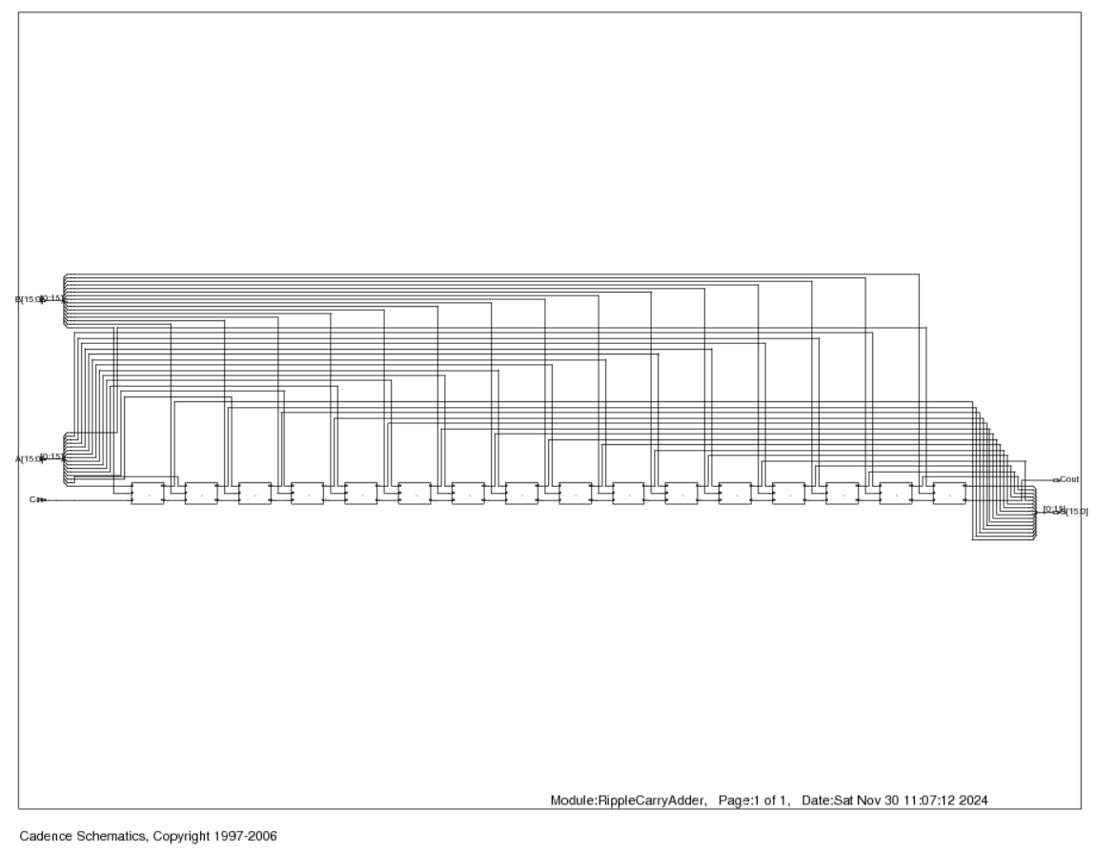

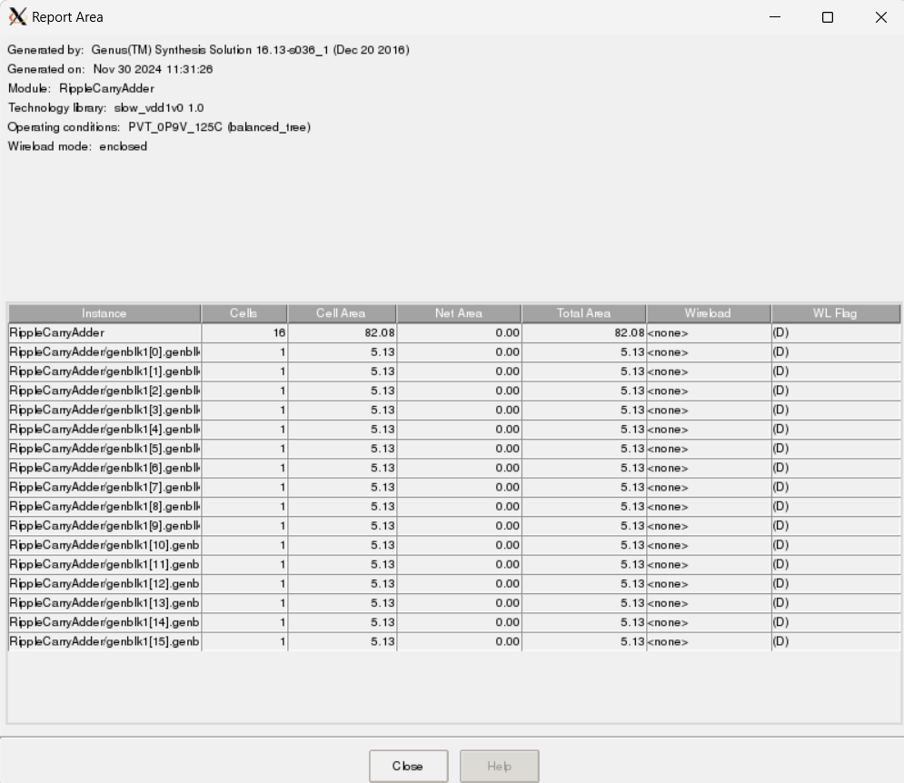

Fig: Area Report

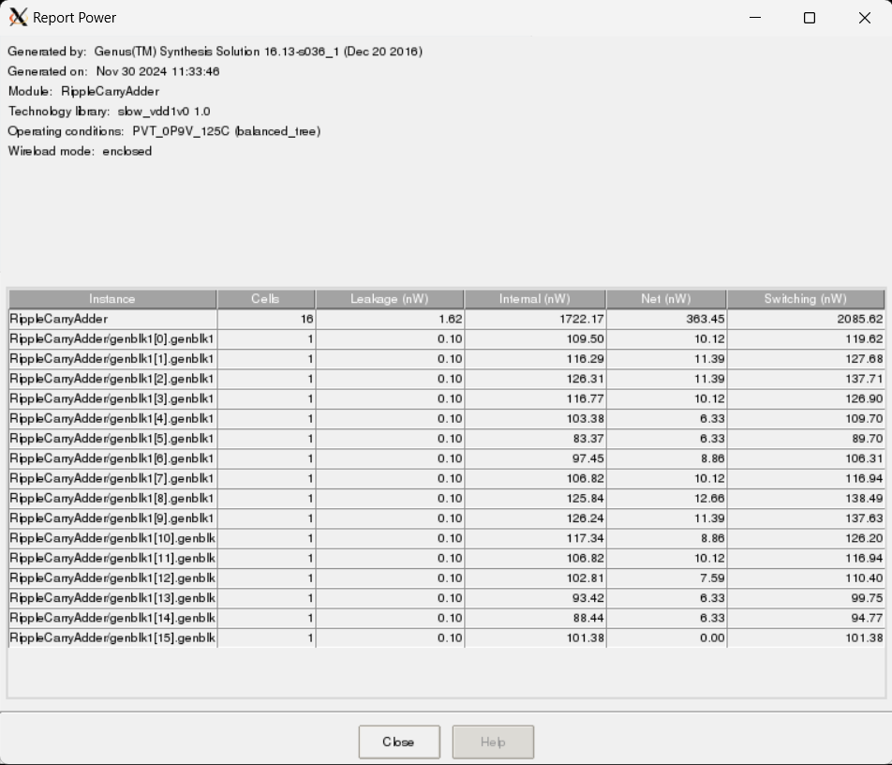

Fig: Power report

**This is the standard cell in synthesized circuit:**

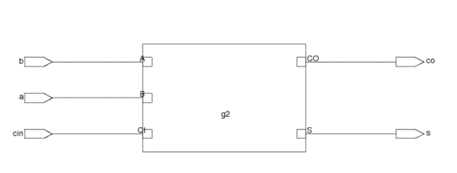

**Details of the standard cell:**

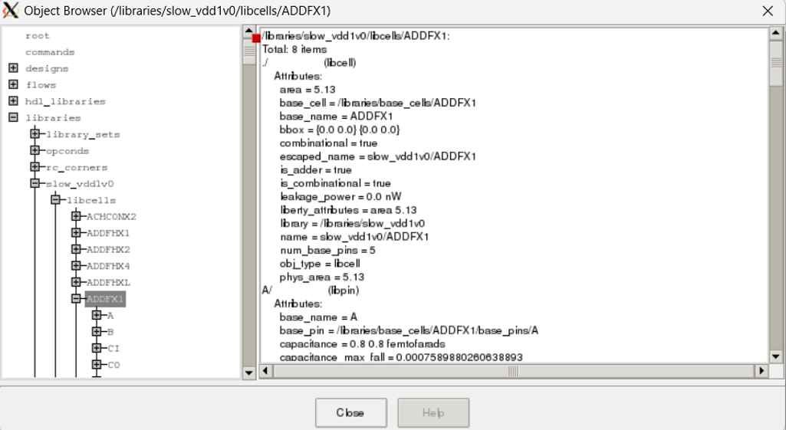

**Observation:**

No relation with clock frequency and input output delay

Optimization needs change in fundamental architecture of the adder

**Synthesis of adder module with clock in Genus:**

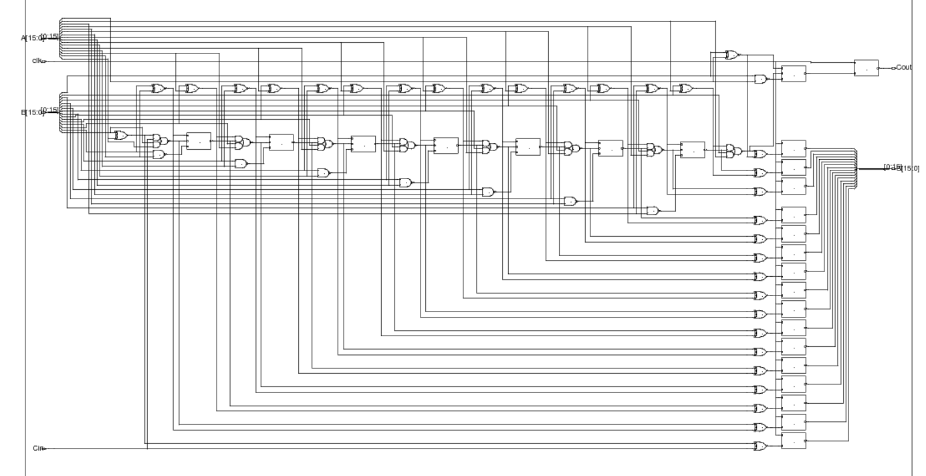

## Optimization

Tuning Parameter range:

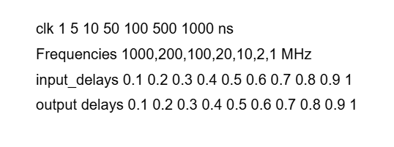

Formula used for weighted sum:



Optimized point for minimum weighted sum:

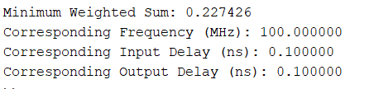

TCL file to generate SDC files according to parameters:

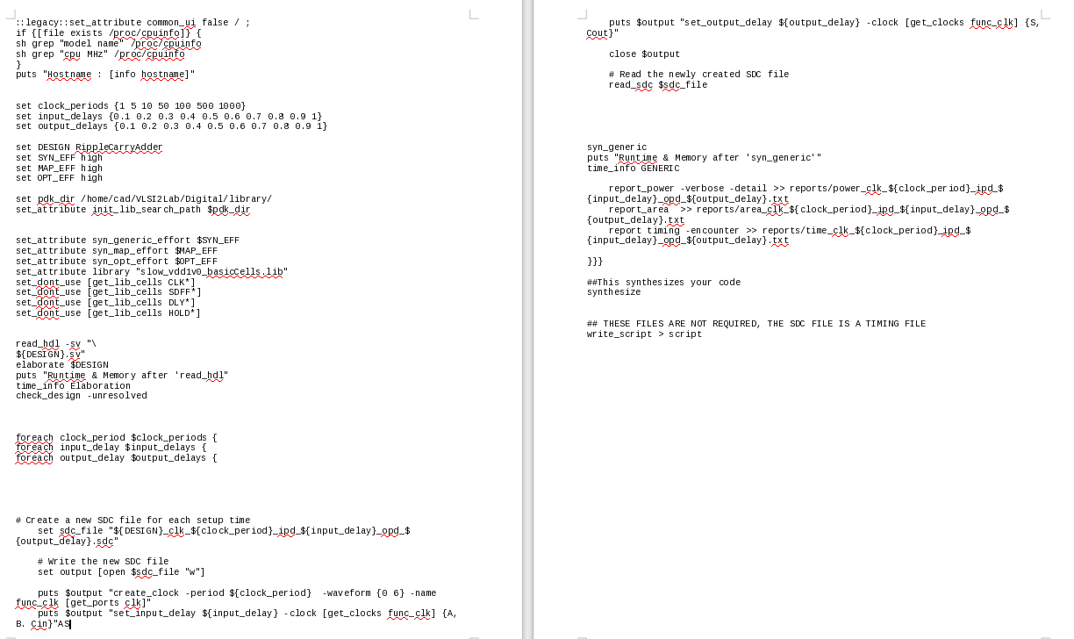

Here the TCL file was coded to write SDC file for each iteration of the input variables and then read the SDC file to generate reports. We ran nested loops to be able to generate reports for variation of each variable. We generated about 2100 reports and then plotted the results using MATLAB for visualization and to understand the trends.

**Variation of Weighted Sum with Tuning Parameters:**

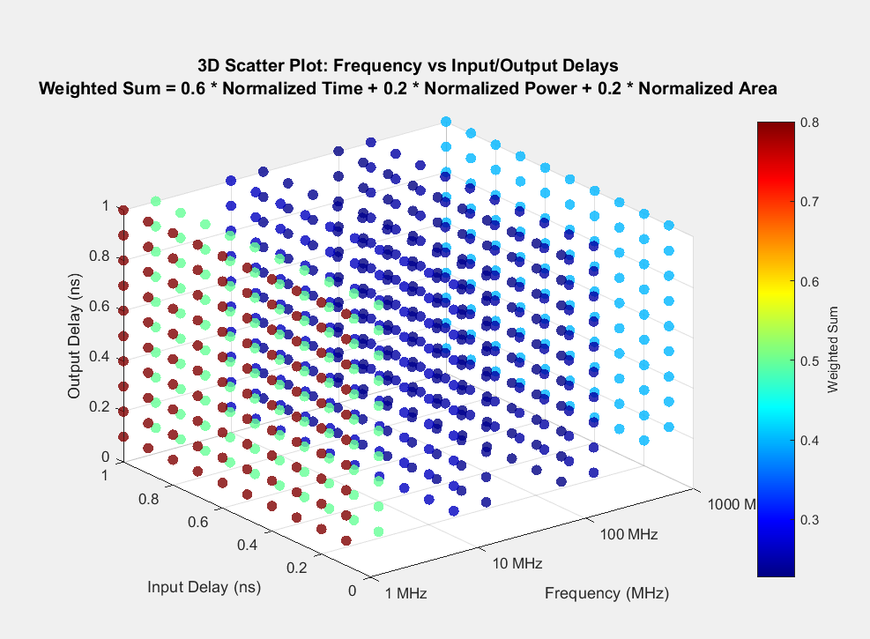

Here the weighted sum is shown as a color gradient where the lower values have a bluer color and higher ones have red color.

**Below is only the output delay vs Frequency plot**

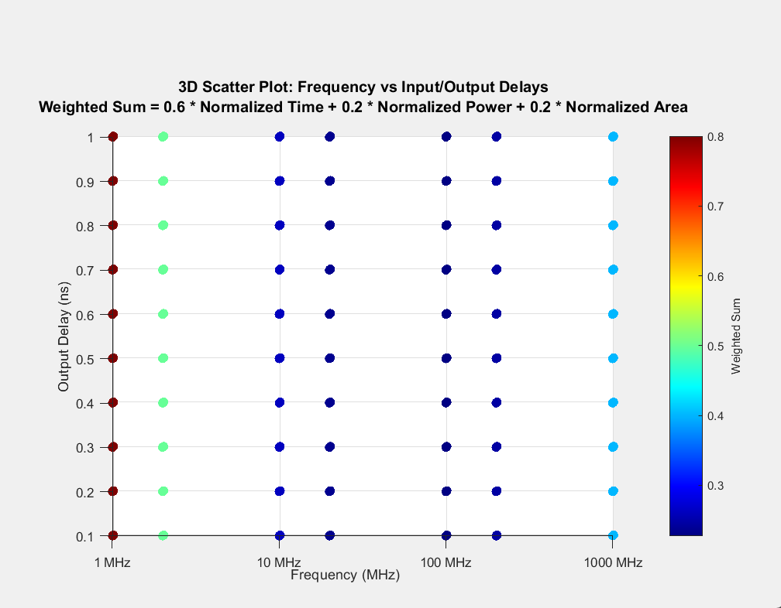

**Below is only the input delay vs Frequency plot**

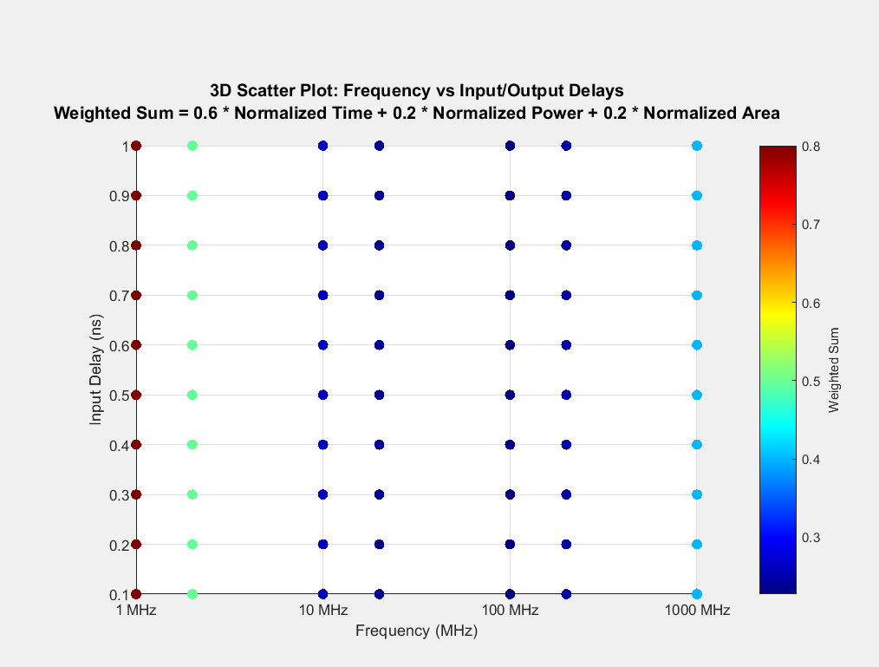

**Plots for Fixed Delay:**

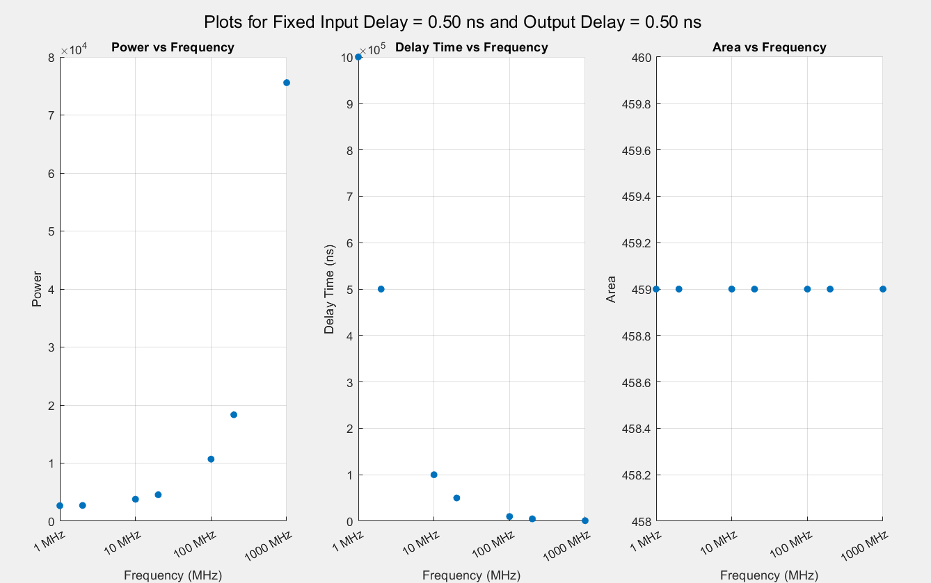

It can be seen that as frequency increases power increases because there are more switching losses, Delay time decreases as clock cycle gets lower and the results can come faster. Area don’t change with frequency

**Plots for Fixed frequency:**

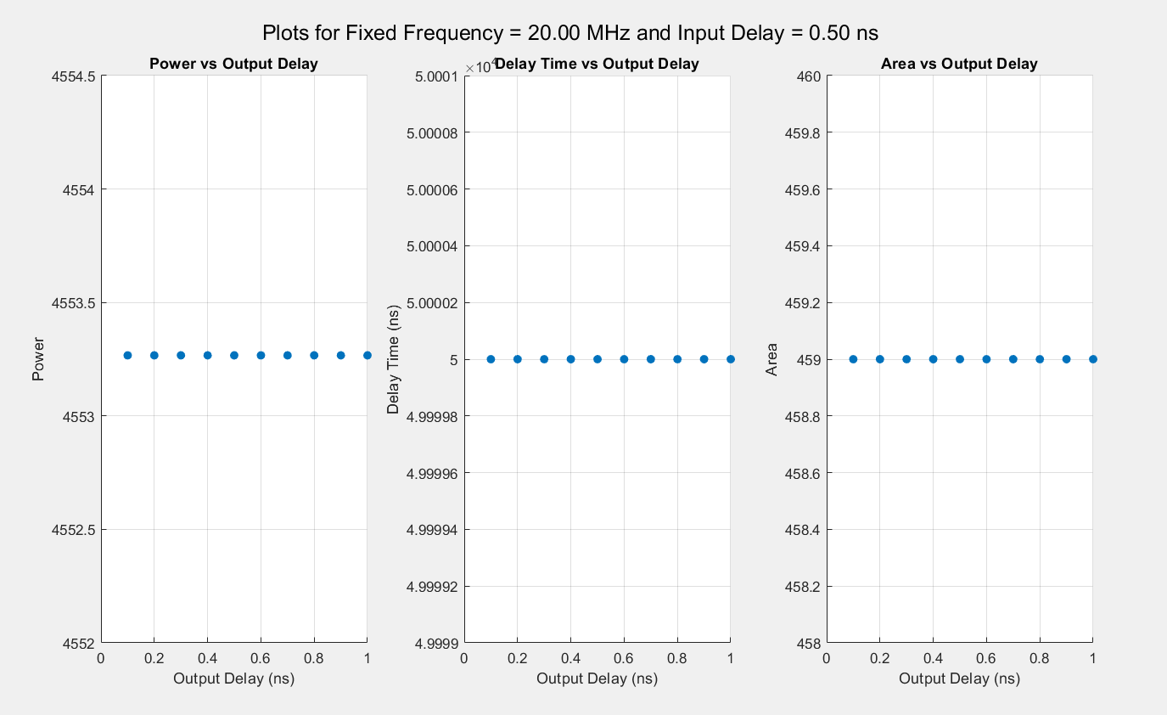

Here the values don’t change with respect to the delay parameter.

**Reports:**

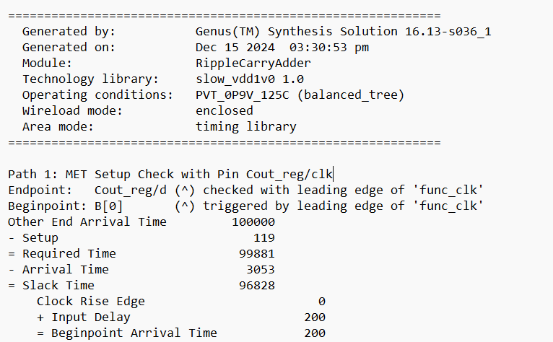

Figure: Timing Report

Here the Other end Arrival time is 100000. This is the Critical path delay time for design with clock.

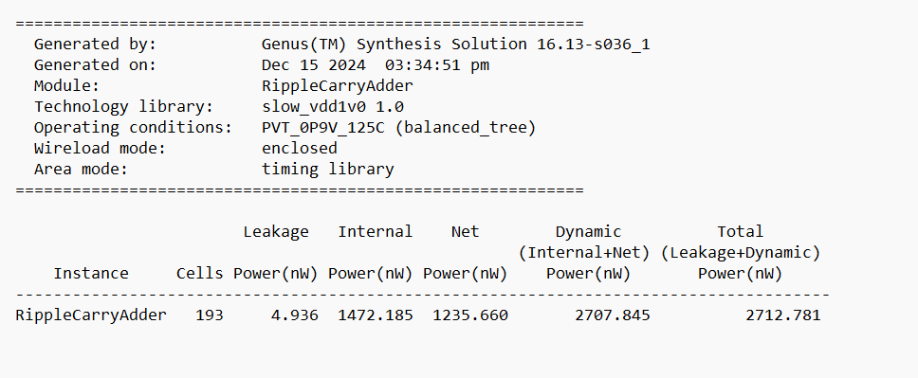

Figure: Power Report

We can see that the total leakage plus dynamic power is 2712.78 nW

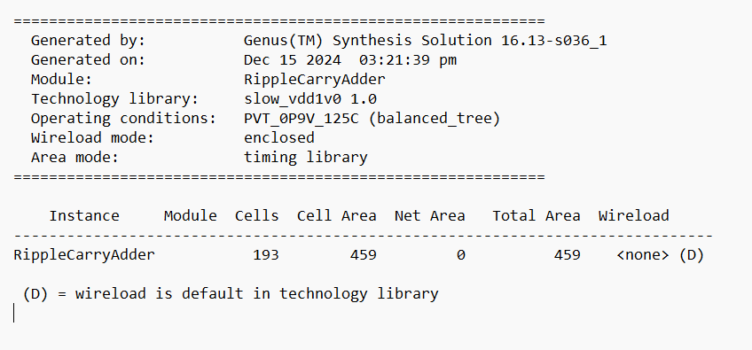

Figure: Area Report

**Observations:**

1. The delay time through the critical path depends only on clock frequency
2. The power requirement increases with high frequency
3. Input and output delay has no effect on power, area or delay time
4. Making the addition synchronized with clock requires more power and area and introduces even more delay in the critical path

# Physical Design (PnR)

Die Size: **20 µm × 20 µm**

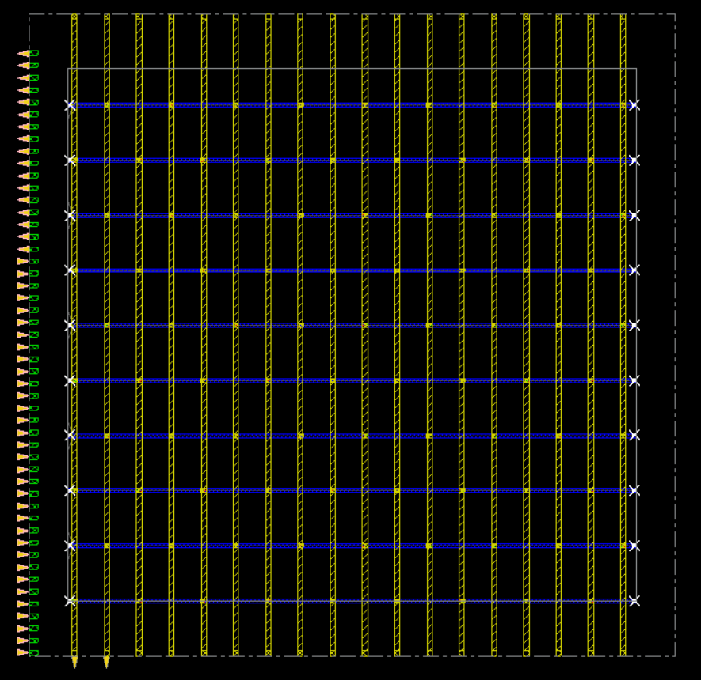

Fig: initial die declaration

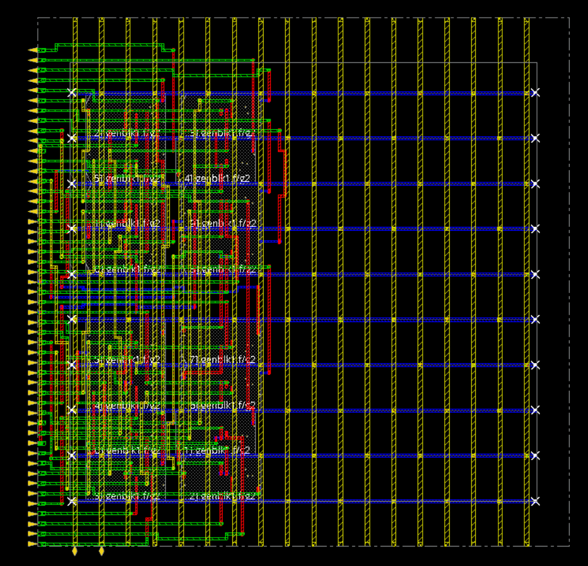

Fig: after cell placement with nano routing

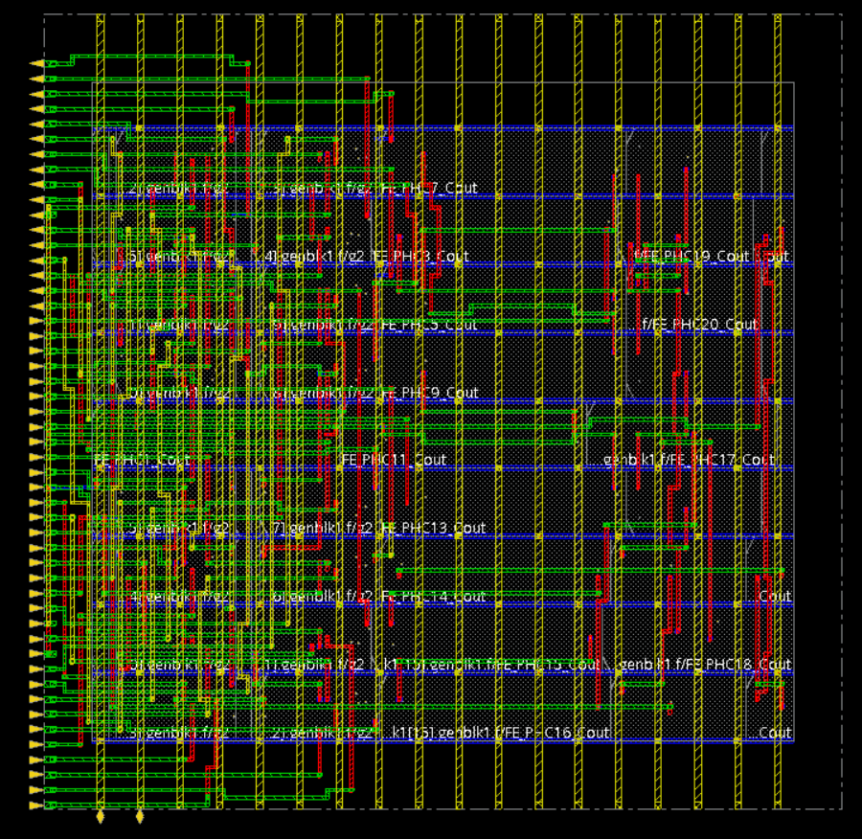

Fig: after filler cell

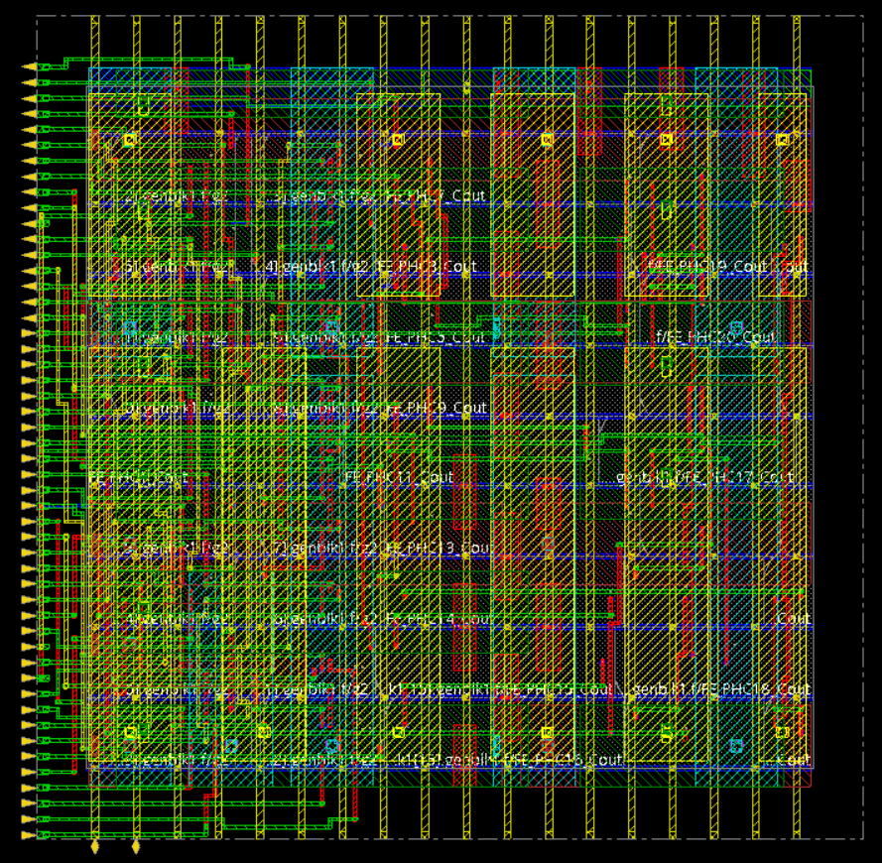

Fig: Layout with metal fill

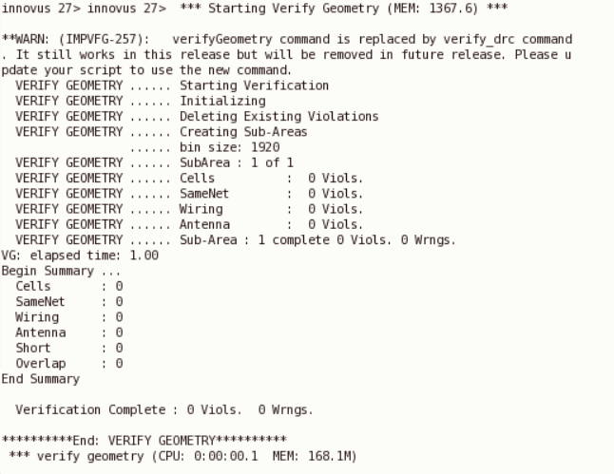

Fig: Verification report

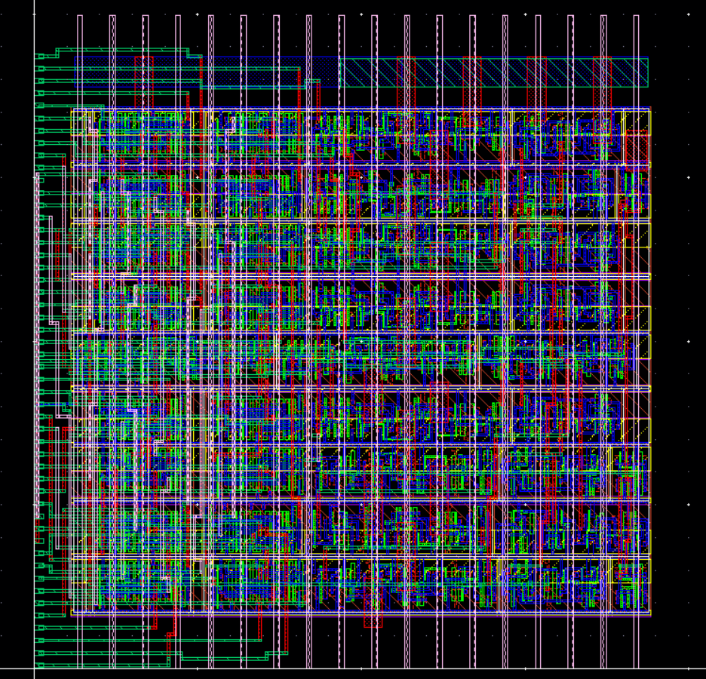

Fig: Final layout

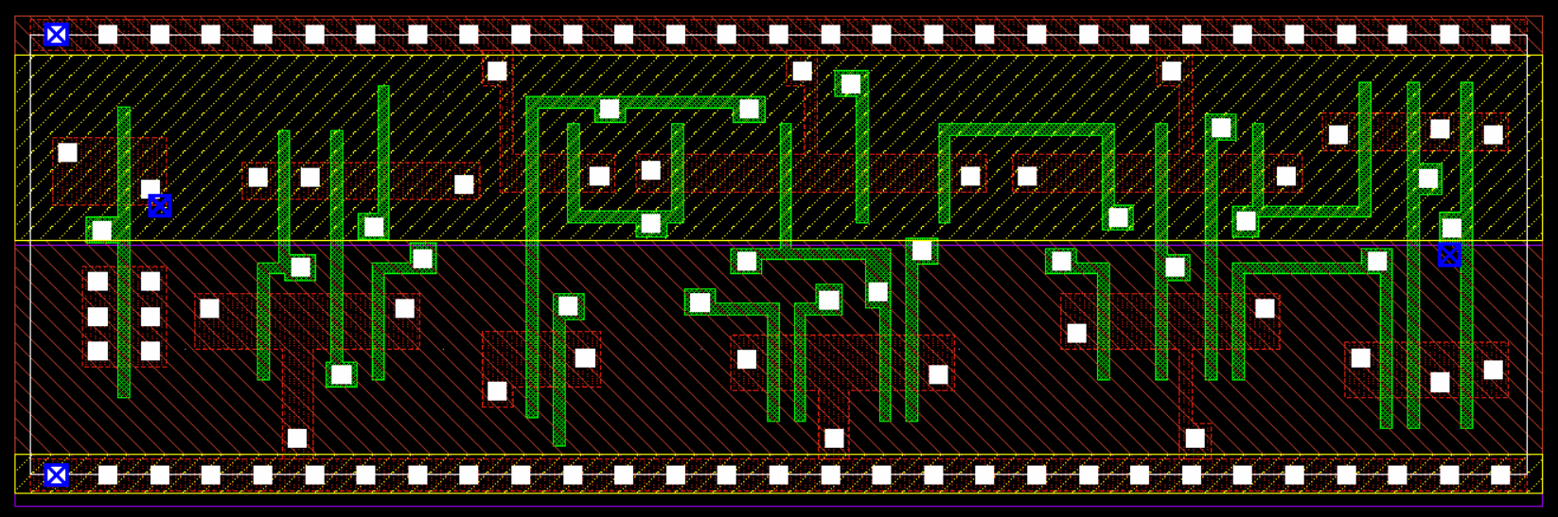

Fig: Zoomed in final layout

**DRC Report:**

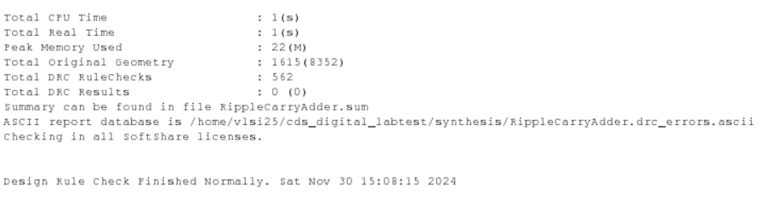

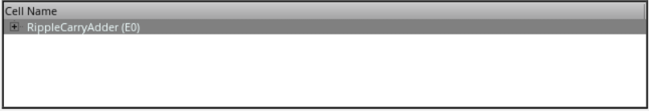

Now we will try to reduce the area for area optimization. We will also distribute the pins on both sides.

**Die Size: 12 µm × 15 µm**

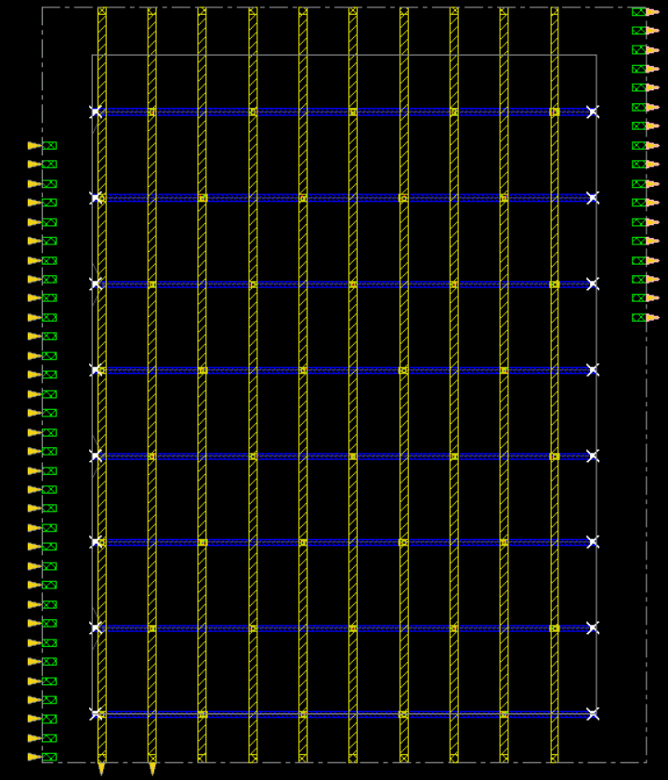

Fig: initial die declaration

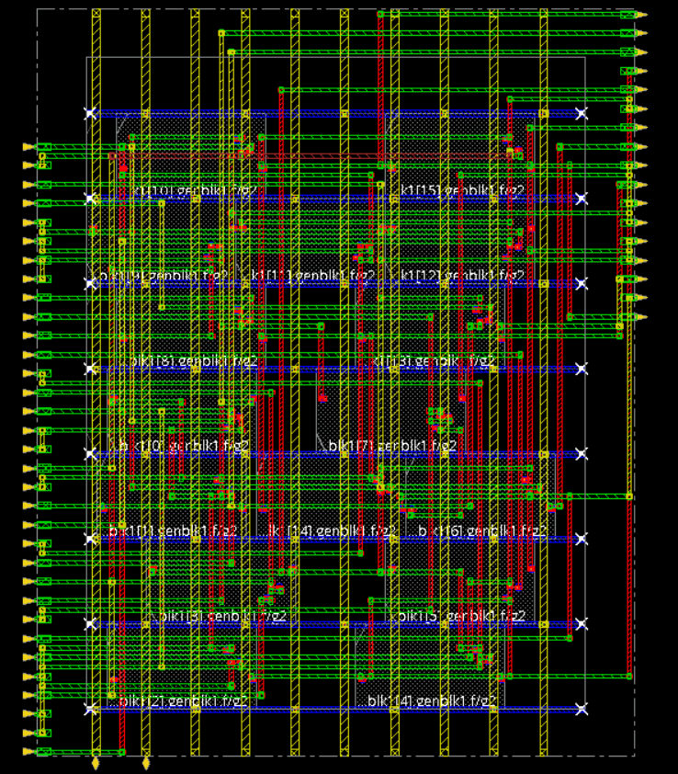

Fig: after cell placement with nano routing

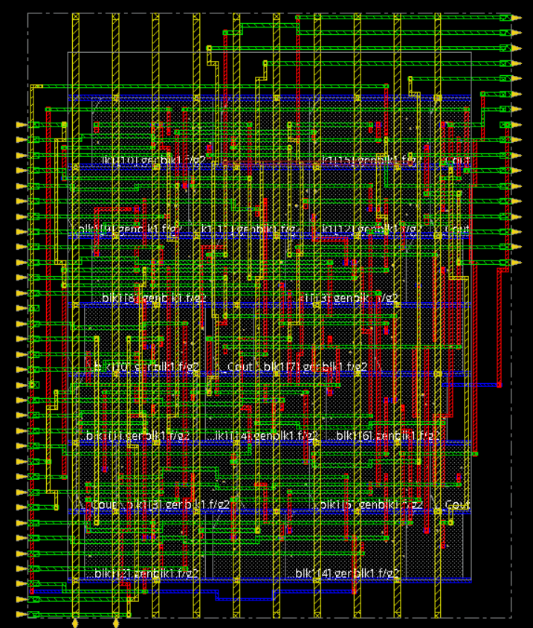

Fig: after Filler Cell

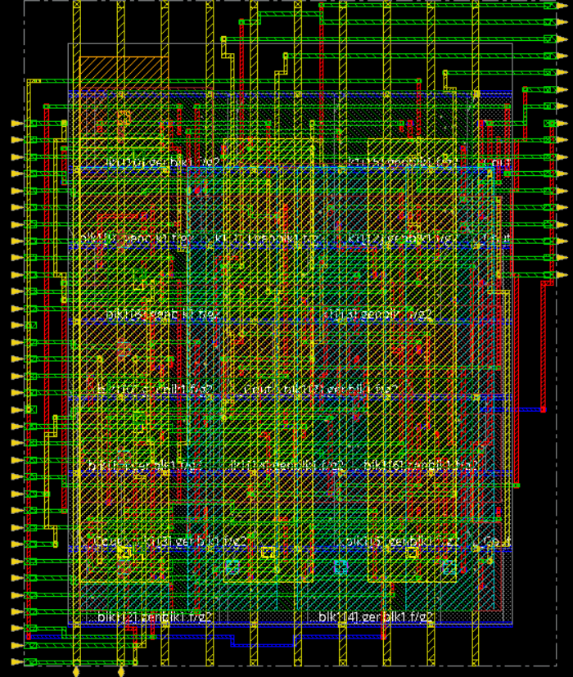

**Fig: metal fill**

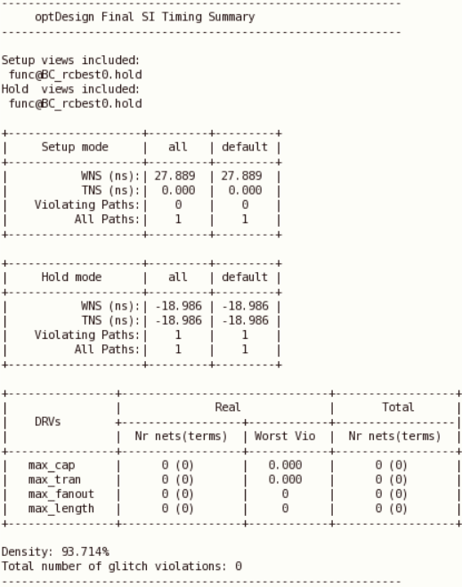

**Fig: optimization summary**

**We can see that the Density is 93.714% This is our most area optimized design.**

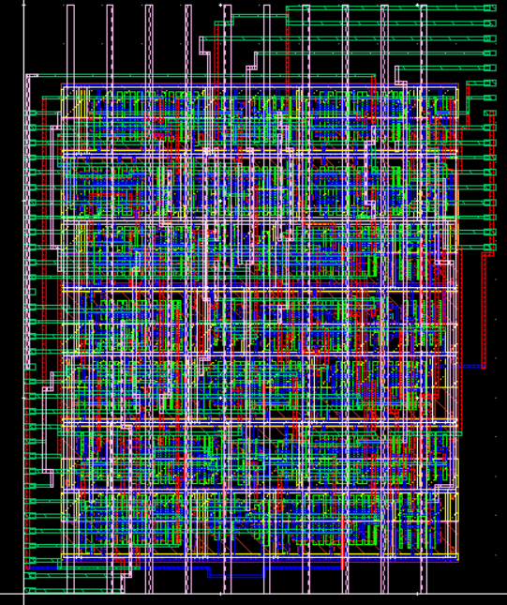

**Fig: Final Layout of the die size 12 µm × 15 µm**

**DRC report shows no error**

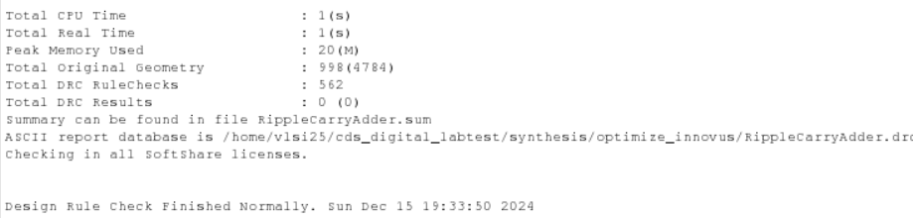

**Now if we try to further reduce the size further, that results in errors.**

**Size: 10 µm × 10 µm**

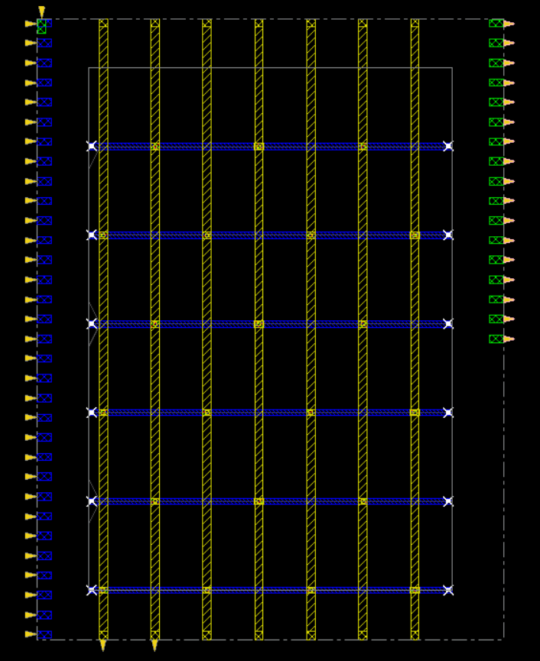

**Fig: initiating die for 10 µm × 10 µm**

**Shows error during cell placement:**



Ultimately Our is design is best optimized at **die size 12 µm × 15 µm. as reducing from there gives density greater than 100%**

**Here’s the summary:**

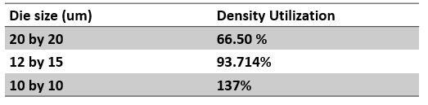

Hence we conclude our design with a die size of 12 by 15 for maximum utilization with error free simulation.

# Future Works

We can use advanced layered testbench to reduce testing times even further. The standard cell of adder can be modified manually to give better delay and other results. The core architecture of the adders need to be improved to tackle the issue like introducing carry look ahead or carry skip adder architecture, PnR can be micro-improved although it may be time consuming.

# References

1. CMOS VLSI Design

A Circuits and Systems Perspective

Neil H. E. Weste

David Money Harris

1. A practical look at system Verilog

Doug Smith

[Dough.smith@doulos.com](mailto:Dough.smith@doulos.com)

1. System Verilog for Verification

3rd editiom

Chris Spear and Greg Tumbush